We said that subnetting is breaking up a network into sub-networks, supernetting is the opposite, it is taking sub-networks and summarising them into a single network.

For example, we can take 2 equal /28 sub-networks (containing 16 IP addresses each) and supernet them into one /29 sub-network (containing 32 IP addresses).

We shall begin by supernetting these 8 equal /28 sub-networks (containing 16 IP addresses each):

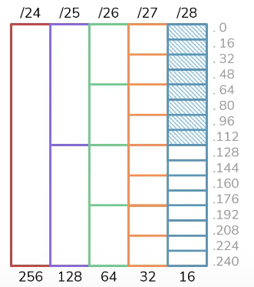

The cheat sheet tells us that a /28 has increments of 16, so the increments have been marked out on the diagram. The network ID’s of each /28 subnet looks like this:

We will use this to supernet the /28 subnets into fewer networks.

We can start by summarising each /28 subnet and summarise them into pairs to supernet them into 4 equal /27 networks:

So now we have this:

These four /27’s are aggregations of the eight /28’s. However, we can take it a step further and summarise each /27 subnet into pairs to supernet them into 2 equal /26 networks:

So now we have two /26’s, these two /26’s are the supernet of the four /27’s and the eight /28’s. But we can take it even further and summarise the 2 equal /26’s and supernet them into one /25.

NEXT PAGE

Now we could go further and summarise these into a /24:

Because technically those eight /28’s absolutely fit into that one /24:

However, if we summarised them into the /24, we would be including the IP addresses which we did not mean to include. We don’t want to include IP’s that are not meant to be included, when we supernet we want to get to the smallest single network possible, meaning 9.9.9.0/25 is the best answer for this subnetting question.

However, it is not always going to be this easy, lets change the problem.

NEXT PAGE

Lets say we wanted to summarise these six /28 networks, notice we removed 2 (unshaded) from the list.

Those 6 still fall into that /25:

If we wanted to summarise those 6 into a single network we could summarise it into a 9.9.9.0/25, but we would be including IP addresses which we did not mean to summarise:

So, when we deal with something more difficult like this, the target isn’t to summarise into the smallest single network, instead it is to summarise into as few networks as possible. So what we can do is this:

NEXT PAGE

We summarise the first two /28 subnets into one /27 subnet, then we summarise the last four /28 subnets into one /26 subnet. Leaving us with one /27 subnet and one /26 subnet which would look like this:

So now we have these 2 options:

Both of these could be the correct answer depending on the question. If we are trying to do routing where we want to direct the 6 sets of IP address (the six /28’s) to a specific next hop, it would be good to use the single network (9.9.9.0/25). But if we are doing access control list which involves giving access from the IP address of the six /28’s to specific resources, then we would use the exact match (9.9.9.0/27, 9.9.9.64/26).

Let’s try solving for this:

NEXT PAGE:

Each /28 subnet has 16 IP addresses. Since we have 8 subnets, if we do 8x16 it gets us 128 total IP addresses. And we can see that a /25 network accounts for 128 IP addresses.

However, if we try to summarise each eight /28 subnets into one /25:

We would only be including the top six /28s. and if we try summarising them into the other /25 which is 9.9.9.128/25, we would only be account for the last two /28s. This is because /25’s always fall on either 9.9.9.0--->9.9.9.27 or from 9.9.9.128--->9.9.9.255. Even though a /25 has enough IP space to account for all 128 IP addresses in the eight /28’s we need to summarise, there is no /25 that starts on 9.9.9.32 and ends on 9.9.9.159.

So, for this problem, due to where the subnets are that we are trying to summarise, we have to go a step further and summarise them all into a /24. That’s the only option we have to summarise all eight /28’s into a single network.

Of course, summarising into a single network (/24) accounts for IP addresses we didn’t mean to include, but that is a common side effect when we are trying to summarise into a single network. However, if we wanted to summarise for an exact match, we would do this:

